13. Create a folder called myteam in your home directory and change its permissions to read only for the owner.

14. Log out and log in by another user

Note I search how can l logout by command and I find this gnome-session quit

15. Try to access (by cd command) the folder (myteam)

16. Using the command Line

• Change the permissions of oldpasswd file to give owner read and write permissions and for group write and execute and execute only for the others (using chmod in 2 different ways)

1



2

• Change your default permissions to be as above.

Here I have a question why when I do this

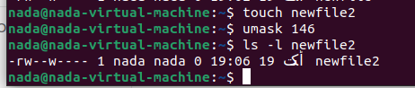

Not follow the mask .. I know the default for files is rw- rw- r--

• What is the maximum permission a file can have, by default when it is just created? And what is that for directory.

default for files is rw- rw- rw-

default for directory rwx rwx rwx

• Change your default permissions to be no permission to everyone then create a directory and a file to verify.

17. What are the minimum permission needed for:

• Copy a directory (permission for source directory and permissions for target parent directory)

* Source directory : read and execute
* target parent directory: write and execute

• Copy a file (permission for source file and and permission for target parent directory)

* Source file : read
* Target parent directory : write and execute

• Delete a file >> no permisson

• Change to a directory >> execute (cd)

• List a directory content (ls command)>> read

• View a file content (more/cat command)>> read

• Modify a file content >> write

18. Create a file with permission 444. Try to edit in it and to remove it? Note what happened.

I can’t edit in it ..

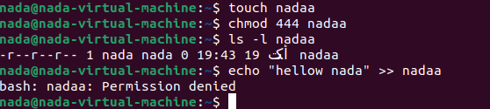

I can remove it ..



19. What is the difference between the “x” permission for a file and for a directory?

* in file: it means running it
* in directory: it means access the directory and see its contents